**EX NO: 5 STRING HANDIND**

**DATE: 20-09-2023**

**AIM**

The aim of the provided Java programs is to implement the String Handing

**ALGORITHM:**

**Step 1: Immutable Strings**

1. Create two strings (str1 and str2) with the same value.
2. Demonstrate the immutability of strings by comparing them.

**Step 2: Reverse String**

1. Request a string input from the user.
2. Reverse the input string and print the result.

**Step 3: Count Occurrences with HashMap**

1. Prompt the user for a string input.
2. Use a HashMap to count the occurrences of each alphabet in the input string.
3. Print the count of each character.

**Step 4: Count Words in a Sentence**

1. Take a sentence input from the user.
2. Split the sentence using spaces (' ') to get individual words.
3. Print the number of words in the sentence.

**Step 5: Check for Palindrome and Anagram**

1. Get a string input from the user.
2. Check if the string is a palindrome and print the result.
3. Get two strings from the user and check if they are anagrams using a HashMap.

**Step 6: Compare Product Versions**

1. Get two product versions as input from the user (e.g., "14.20.50").
2. Split each version using '.' and compare each part.
3. Print which version is larger.

**Step 7: Validate Email**

1. Obtain an email ID from the user.
2. Split the email using '@' and validate its format.
3. Check if the domain is valid based on a predefined list.

**Step 8: Dictionary Lookup**

1. Declare a 2-dimensional array with words and their meanings.
2. Get a word input from the user.
3. Print the meaning if the word exists in the dictionary.

**Step 9: Hangman Game**

1. Implement a hangman game where the user guesses a word by suggesting letters.
2. Provide two clues that reduce chances when requested.
3. Declare if the user won or lost based on the guesses and chances.

**1. Practice string methods Write a java program to perform string methods by considering the given string inputs String**

**s1=”Welcome to Java”;**

**String s2=s1;String s3=new**

**String(“Welcome to Java”);**

**String s4=s1.intern();**

**CODE**

public class Bhumi3704 {

public static void main(String[] args) {

System.out.println("Bhumisvara");

System.out.println("2021503704" );

String s1 = "Welcome to Java";

String s2 = s1;

String s3 = new String("Welcome to Java");

String s4 = s1.intern();

System.out.println("(1) s1 == s2: " + (s1 == s2));

System.out.println("(2) s2 == s3: " + (s2 == s3));

System.out.println("(3) s1.equals(s2): " + s1.equals(s2));

System.out.println("(4) s2.equals(s3): " + s2.equals(s3));

System.out.println("(5) s1.compareTo(s2): " + s1.compareTo(s2));

System.out.println("(6) s2.compareTo(s3): " + s2.compareTo(s3));

System.out.println("(7) s1 == s4: " + (s1 == s4));

System.out.println("(8) s1.charAt(0): " + s1.charAt(0));

System.out.println("(9) s1.indexOf('j'): " + s1.indexOf('j'));

System.out.println("(10) s1.indexOf(\"to\"): " + s1.indexOf("to"));

System.out.println("(11) s1.lastIndexOf('a'): " + s1.lastIndexOf('a'));

System.out.println("(12) s1.lastIndexOf(\"o\", 15): " + s1.lastIndexOf("o", 15));

System.out.println("(13) s1.length(): " + s1.length());

System.out.println("(14) s1.substring(5): " + s1.substring(5));

System.out.println("(15) s1.substring(5, 11): " + s1.substring(5, 11));

System.out.println("(16) s1.startsWith(\"Wel\"): " + s1.startsWith("Wel"));

System.out.println("(17) s1.endsWith(\"Java\"): " + s1.endsWith("Java"));

System.out.println("(18) s1.toLowerCase(): " + s1.toLowerCase());

System.out.println("(19) s1.toUpperCase(): " + s1.toUpperCase());

System.out.println("(20) \" Welcome \".trim(): " + " Welcome ".trim());

System.out.println("(21) s1.replace('o', 'T'): " + s1.replace('o', 'T'));

System.out.println("(22) s1.replaceAll(\"o\", \"T\"): " + s1.replaceAll("o", "T"));

System.out.println("(23) s1.replaceFirst(\"o\", \"T\"): " + s1.replaceFirst("o", "T"));

}

}

**OUTPUT**

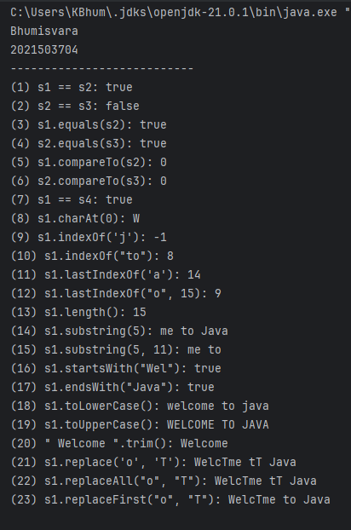

**2. String reverse Write a java program to read the string and displays the reverse of the string.**

**CODE**

import java.util.Scanner;

public class Bhumi3704 {

public static void main(String[] args) {

Scanner scanner = new Scanner(System.in);

System.out.println("Bhumisvara");

System.out.println("2021503704");

System.out.print("Enter a string: ");

String input = scanner.nextLine();

String reversed = reverseString(input);

System.out.println("Reversed string: " + reversed);

scanner.close();

}

public static String reverseString(String input) {

StringBuilder reversed = new StringBuilder();

for (int i = input.length() - 1; i >= 0; i--) {

reversed.append(input.charAt(i));

}

return reversed.toString();

}

}

**OUTPUT**

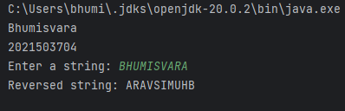

**3. Letter occurrence Write a java program to count the number of occurrence of the each letter in the given string.**

**CODE**

import java.util.HashMap;

import java.util.Map;

import java.util.Scanner;

public class Bhumi3704 {

public static void main(String[] args) {

Scanner in =new Scanner (System.in);

System.out.println("Bhumisvra");

System.out.println("2021503704");

System.out.println("Enter the String");

String input =in.nextLine();

Map<Character, Integer> letterFrequency = new HashMap<>();

input = input.replaceAll("\\s", "").toLowerCase();

for (char ch : input.toCharArray()) {

if (Character.isLetter(ch)) {

letterFrequency.put(ch, letterFrequency.getOrDefault(ch, 0) + 1);

}

}

System.out.println("Letter Frequencies:");

for (Map.Entry<Character, Integer> entry : letterFrequency.entrySet()) {

char letter = entry.getKey();

int frequency = entry.getValue();

System.out.println("'" + letter + "': " + frequency);

}

}

}

**OUTPUT**

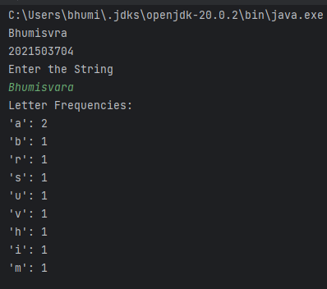

**4. Count Words Write a Java program to count the number of words in the given string.**

**CODE**

import java.util.Scanner;

public class Bhumi3704 {

public static void main(String[] args) {

System.out.println("Bhumisvra");

System.out.println("2021503704");

Scanner in =new Scanner (System.in);

System.out.println("Enter the String");

String input =in.nextLine();

String[] words = input.split("[\\s\\p{Punct}]+");

int wordCount = words.length;

System.out.println("Number of words in the string: " + wordCount);

}

}

**OUTPUT**

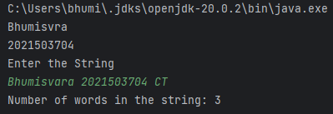

**5. Palindrome and anagram**

**i.Write a java program to check the given string is palindrome not**

**(Example:Race car)**

**CODE**

import java.util.*;

public class Bhumi3704 {

public static void main(String[] args) {

Scanner in =new Scanner (System.in);

System.out.println("Bhumisvara");

System.out.println("2021503704");

System.out.println("Enter the String");

String input =in.nextLine();

String cleanInput = input.replaceAll("\\s", "").toLowerCase();

boolean isPalindrome = isPalindrome(cleanInput);

if (isPalindrome) {

System.out.println("\"" + input + "\" is a palindrome.");

} else {

System.out.println("\"" + input + "\" is not a palindrome.");

}

}

public static boolean isPalindrome(String str) {

int left = 0;

int right = str.length() - 1;

while (left < right) {

if (str.charAt(left) != str.charAt(right)) {

return false;

}

left++;

right--;

}

return true;

}

}

**OUTPUT**

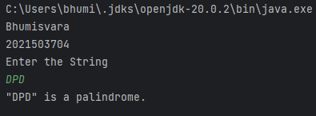

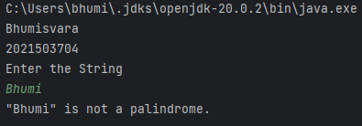

**ii. Write a java program to check the given string is anagram or not(Example Iceman vs Cinema)**

**CODE**

import java.util.Arrays;

import java.util.Scanner;

public class Bhumi3704 {

public static void main(String[] args) {

System.out.println("Bhumisvara");

System.out.println("20215035704");

Scanner in =new Scanner (System.in);

System.out.print("Enter the string 1");

String str1= in.nextLine();

System.out.print("Enter the string 2");

String str2= in.nextLine();

String cleanedStr1 = str1.replaceAll("\\s", "").toLowerCase();

String cleanedStr2 = str2.replaceAll("\\s", "").toLowerCase();

boolean areAnagrams = areAnagrams(cleanedStr1, cleanedStr2);

if (areAnagrams) {

System.out.println("\"" + str1 + "\" and \"" + str2 + "\" are anagrams.");

} else {

System.out.println("\"" + str1 + "\" and \"" + str2 + "\" are not anagrams.");

}

}

public static boolean areAnagrams(String str1, String str2) {

if (str1.length() != str2.length()) {

return false;

}

char[] charArray1 = str1.toCharArray();

char[] charArray2 = str2.toCharArray();

Arrays.sort(charArray1);

Arrays.sort(charArray2);

return Arrays.equals(charArray1, charArray2);

}

}

**OUTPUT**

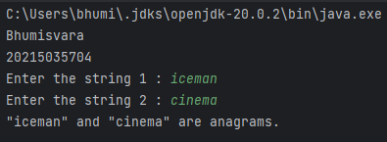

**6. Comparison of product version number**

**Write a java program that read a two string of the given format and compares the string Example:15.10.10 is greater than 14.20.50 as 15 >1414.12.10 is greater than 14.10.55 as 12>1014.10.15 is greter than 14.10.11 as 15>11Hint:Given String.split(\\.)**

**CODE**

public class Bhumi3704 {

public static void main(String[] args) {

System.out.println("Bhumisvara");

System.out.println("20215035704");

String str1 = "15.10.10";

String str2 = "14.20.50";

int comparisonResult = compareStrings(str1, str2);

if (comparisonResult > 0) {

System.out.println(str1 + " is greater than " + str2);

} else if (comparisonResult < 0) {

System.out.println(str1 + " is less than " + str2);

} else {

System.out.println(str1 + " is equal to " + str2);

}

}

public static int compareStrings(String str1, String str2) {

String[] parts1 = str1.split("\\.");

String[] parts2 = str2.split("\\.");

for (int i = 0; i < Math.min(parts1.length, parts2.length); i++) {

int num1 = Integer.parseInt(parts1[i]);

int num2 = Integer.parseInt(parts2[i]);

if (num1 < num2) {

return -1;

} else if (num1 > num2) {

return 1;

}

}

return Integer.compare(parts1.length, parts2.length);

}

}

**OUTPUT**

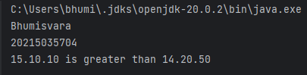

**7. Email validity Write a java program using String methods to compare the email is valid is invalid and returns the username and domain name**

**CODE**

import java.util.regex.Matcher;

import java.util.regex.Pattern;

import java.util.*;

public class Bhumi3704 {

public static void main(String[] args) {

Scanner in =new Scanner (System.in);

System.out.println("Bhumisvara");

System.out.println("20215035704");

System.out.println("Enter the String");

String email =in.nextLine();

String regex = "^[a-zA-Z0-9_+.-]{1,}@[a-zA-Z0-9.-]+\\.(com|in|edu)$";

Pattern pattern = Pattern.compile(regex);

Matcher matcher = pattern.matcher(email);

if (matcher.matches()) {

System.out.println("Email is valid.");

String[] parts = email.split("@");

String username = parts[0];

String domain = parts[1];

System.out.println("Username: " + username);

System.out.println("Domain: " + domain);

} else {

System.out.println("Email is invalid.");

}

}

}

**OUTPUT**

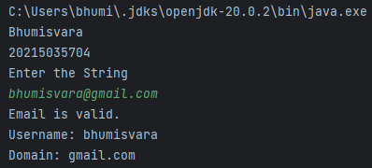

1. ***Write a java program to create a dictionary using 2D string array for any 10 programming languages.Write a method that return the definition for the input of PL name.***

**CODE**

import java.util.Scanner;

public class Dictionary {

public static void main(String[] args) {

String[][] dictionary = {

{"Java", "Java is a pure object-oriented programming language created by James Gosling."},

{"C++", "C++ is an object-oriented programming language created by Bjarne Stroustrup."},

{"Python", "Python is an interpreted, high-level, general-purpose programming language."},

{"JavaScript", "JavaScript is a scripting language commonly used for web development."},

{"Ruby", "Ruby is a dynamic, object-oriented programming language known for its simplicity."},

{"Swift", "Swift is a statically-typed programming language developed by Apple for iOS app development."},

{"C#", "C# is a modern, object-oriented programming language developed by Microsoft."},

{"PHP", "PHP is a server-side scripting language commonly used for web development."},

{"Kotlin", "Kotlin is a statically-typed programming language that runs on the Java Virtual Machine (JVM)."},

{"Rust", "Rust is a systems programming language known for its memory safety and performance."},

};

Scanner in =new Scanner (System.in);

System.out.println("Bhumisvara");

System.out.println("20215035704");

System.out.println("Enter the String");

String language =in.nextLine();

String definition = getDefinition(dictionary, language);

if (definition != null) {

System.out.println(language+ ": " + definition);

} else {

System.out.println("Programming language not found in the dictionary.");

}

}

public static String getDefinition(String[][] dictionary, String languageName) {

for (String[] entry : dictionary) {

String name = entry[0];

String definition = entry[1];

if (name.equalsIgnoreCase(languageName)) {

return definition;

}

}

return null;

}

}

**OUTPUT**

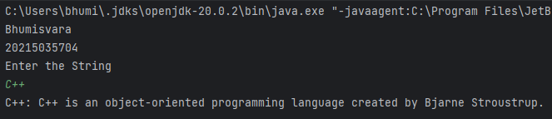

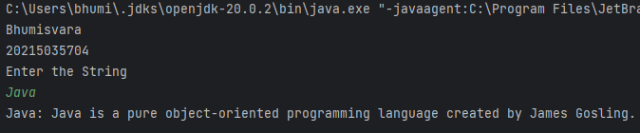

**9. Hangman Game Development**

**Write a program to implement Hangman game in Java, a word-guessing game where one player thinks of a Secret word, and another player (the computer i.e., Guesser or user) tries to guess it by stating one letter at a time.If the guessed letter is in the secret word, it's revealed in the display; otherwise the number of attempt is reduced by one.**

**CODE:**

import java.util.Random;

import java.util.Scanner;

public class Hangman {

private static final int MAX_ATTEMPTS = 7;

public static void main(String[] args) {

System.out.println("Bhumisvara");

System.out.println("2021503704");

Scanner scanner = new Scanner(System.in);

String secretWord = generateSecretWord();

boolean[] guessedLetters = new boolean[secretWord.length()];

int attempts = 0;

while (attempts < MAX_ATTEMPTS) {

System.out.println("The word is: ");

for (int i = 0; i < secretWord.length(); i++) {

if (guessedLetters[i]) {

System.out.print(secretWord.charAt(i));

} else {

System.out.print("_");

}

}

System.out.println();

System.out.println("Guess a letter: ");

char guess = scanner.next().charAt(0);

if (!Character.isAlphabetic(guess)) {

System.out.println("Invalid guess. Please enter a letter.");

continue;

}

boolean isCorrectGuess = false;

for (int i = 0; i < secretWord.length(); i++) {

if (secretWord.charAt(i) == guess) {

guessedLetters[i] = true;

isCorrectGuess = true;

}

}

if (!isCorrectGuess) {

attempts++;

}

if (isWordGuessed(guessedLetters)) {

System.out.println("You win!");

break;

} else if (attempts == MAX_ATTEMPTS) {

System.out.println("You lose! The secret word was: " + secretWord);

break;

}

}

System.out.println("Do you want to play again? (y/n)");

char playAgain = scanner.next().charAt(0);

if (playAgain == 'y') {

main(args);

} else {

System.out.println("Thank you for playing!");

}

}

private static String generateSecretWord() {

String[] secretWords = {

"hello", "world", "hangman", "programming", "java", "computer", "Bhumisvara"

};

Random random = new Random();

return secretWords[random.nextInt(secretWords.length)];

}

private static boolean isWordGuessed(boolean[] guessedLetters) {

for (boolean guessedLetter : guessedLetters) {

if (!guessedLetter) {

return false;

}

}

return true;

}

}

**OUTPUT:**

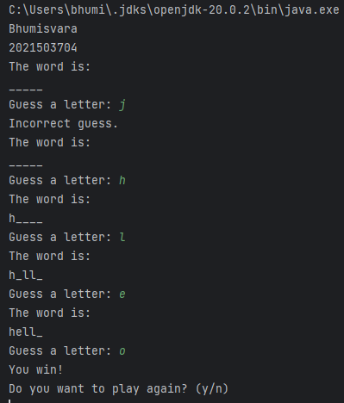

**RESULT:**

String class in java along with its methods implemented successfully.